
B2U4SESSION 07: “MY FAMILY BUDGET”
Competency: | Reads different kinds of text in English as a foreign language
Objective: | To identify and organize income and expenses, solve problems and design their own family budget using simple English.
1.- VOCABULARY. Match the word to the definition.
Income | ○ Money you spend
Expense | ○ Money you receive
Budget | ○ Keep money for the future
Save | ○ Financial plan
2.- READ THE TEXT. Underline the words from the vocabulary.

The Garcia family has a monthly income of S/.3,200. Every month they pay for rent, food, electricity, water, transportation and school supplies.
Before buying new clothes or electronic devices, they check their budget. They always save 10% of their income for emergencies.
Sometimes they want to buy expensive things, but they know saving money helps them prepare for the future because they have a budget, the Garcia family feels safe and organized.
3.- Write “True” or “False”
_______ The Garcia family saves money every month.
_______ They buy everything they want.
_______ They save money for emergencies.
_______ They spend aal their income.

4.- Answer the questions.
a. How much money does the family earn every month?
___________________________________________________________________________
b. What do they pay every month?
___________________________________________________________________________
c. Why do they save money?
____________________________________________________________________________
d. What do they do before buying expensive things?
___________________________________________________________________________
5.- Complete the budget.
INCOME | AMOUNT | Water
Family income | S/. 4,000 | Electricity
EXPENSES | AMOUNT | Transportation
Food |  | School supplies
Rent |  | Savings

Question: How much money does the family save? ______________________________________
6.- NEEDS or WANTS
🍎 Apples |  | 🎮 Video game
📱 New smartphone |  | 🏠 House rent
💊 Medicine |  | 👟 New shoes for school

7.-SPEAKING ACTIVITY: Work with a partner. Ask and answer.
A: What does your family spend money on?
B: My family spends money on ………………………………………………………………….
A: Is saving money important?
B: Yes, because ………………………………………………………………………………………

8.- DESIGN YOUR OWN FAMILY BUDGET. Imagine your family has S/.4,000 for one month. Create a table.

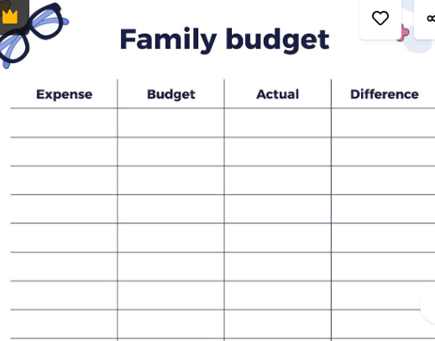
💡 electricity bill

💧water Bill

🛒 shopping

📱 cellphone

🏠 rent

internet
SAVINGS:

