READING: TWO FAMILIES AT THE FESTIVAL
- Vocabulary
- Spending money= | Using your money to buy things you want or need.
- Saving money = | Keeping your money for the future instead of using it now.
- Budget = | A plan that shows how much money you earn and how you spend it.
- Scarves = | Pieces of cloth you wear around your neck to stay warm (plural of scarf).
- Profit = | The extra money you make when you sell something for more than it cost.
- Wasting money = | Spending money on bad things or things you do not really need.
- Making money = | Getting money by working, doing a job, or selling products.

- Read the following texts and create a “Comparative chart”

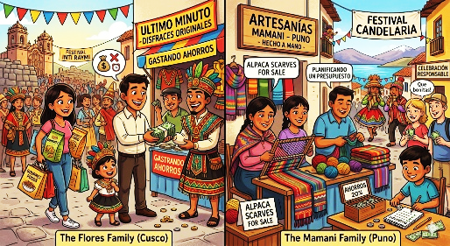
- The Flores Family (Cusco) Today is the Inti Raymi festival! The Flores family is very happy, but they have financial problems. Right now, they are spending all their savings. They are buying expensive food and original costumes at the last minute. They aren't saving money for emergencies and they aren't planning a budget.

- The Mamani Family (Puno) Today is the Candelaria festival! The Mamani family is celebrating responsibly. Right now, they are making beautiful alpaca scarves to sell to the tourists. They are saving 20% of their money. They aren't wasting money on expensive things because they are planning a budget. They are making a profit!

Example:

Financial Actions  (Present Continuous) | The Flores Family (Cusco) | The Mamani Family (Puno)
What are they doing with money?  (Afirmative statements) | 1..  2.. | 1..  2..
What are they NOT doing?  (Negative statements) | 1..  2.. | 1..  2..
Financial Status:
(Good or bad decision?)

